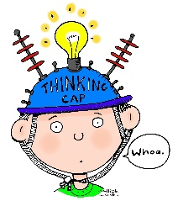
Science Transition Project

Create a poster to illustrate a ‘journey’, while you are researching try to imagine all the amazing journeys that take place and how science makes them possible.
Here are some ideas to get you started:
- Research famous journeys; e.g. Amy Johnson’s flight alone from Britain to Australia, Charles Darwin’s journey on the HMS Beagle or Perseverance – The Mars Rover.
- Think about journeys that might be made in the future or travels through time.
- Create a design for a transport vehicle for the future. How would it be different from cars or airplanes?
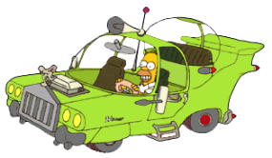
- Journeys into space or under water- how are these possible? What would we need to live under water or in space?
- Other than travel, what other journeys can you think of? E.g. life cycles, or the life cycles of materials such as plastics.
Your poster must be 2D (flat). If you make a model, please take a photo of it on A4 or A3 paper. You can use pop up pictures, pull out tabs or use materials such as paint, drawing pencils, crayons and paper.
Extension / Challenge Task
Write, in no more than 200 words, about an important person in STEM (Science, Technology, Engineering and Maths), past or present, whom you relate to and who inspires you. Explain what they did and how that has interested you in Science.
