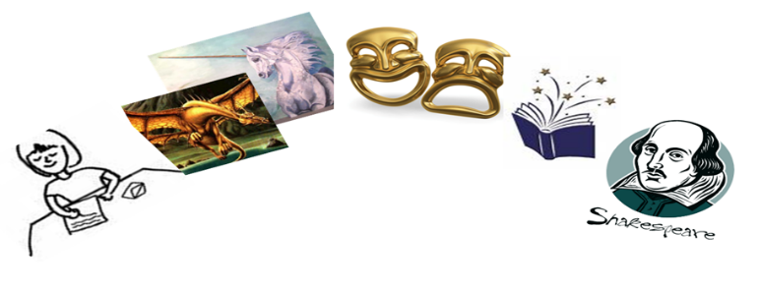
English Transition Project
Create any of the following in order to reflect your own ‘identity’:
- A poster: Title, subtitle, images, effective use of colour, key information about your identity.
- A booklet: Front cover, images, effective use of colour, information divided into sections, information written in full sentences and in bullet points.
- A story: create a story that reflects your identity; it doesn’t have to be true if you don’t want it to be. Perhaps you could write a story about being kind or describe an important event in your life.
- A poem: Free verse, rhyming, acrostic, haiku, epic.
Try to complete research into your own identity. Here are some ideas to get you started:
- Have you ever demonstrated any heroic qualities? Consider the following: being kind, brave, a role model, putting others before yourself, mental or physical strength etc.
- Think about your own personality traits and consider whether they have always been there.
- Has your identity ever changed at all and why might this be?
- What external factors might have influenced a change in your identity?
- Speak to whoever you live with about your history. See how many generations you can go back to. Has this shaped your identity now?
- Can you think of an event that might have had or could have an impact on your identity? For example, starting at Coundon Court.
You will need to hand in your project to your Year 7 English teacher when you arrive at Coundon Court

